**Installation of PostgreSQL on Ubuntu through Ansible-Galaxy**

* Firstly, create two instances in EC2(one for manual run and another for automation).

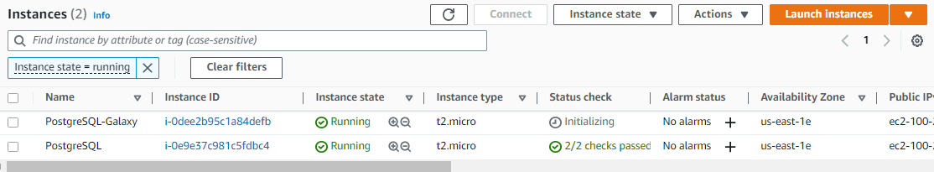

* Log into the VMs.

**$** 🡪 **(ssh ubuntu@public_ip_address)**

* Install Ansible in both the VMs.

**$** 🡪 **(sudo apt update)**

**$ 🡪 (sudo apt install ansible)**

* Open any document to install “PostgreSQL” manually. Refer here for document(<https://www.digitalocean.com/community/tutorials/how-to-install-and-use-postgresql-on-ubuntu-22-04>).

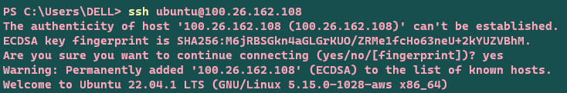

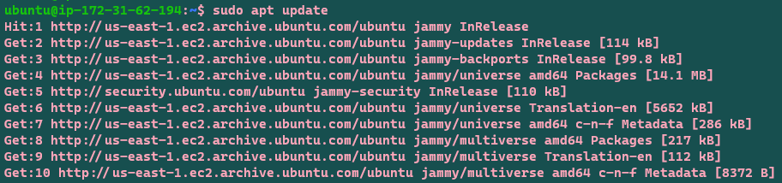

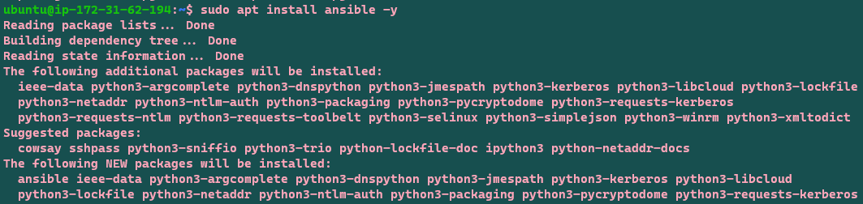

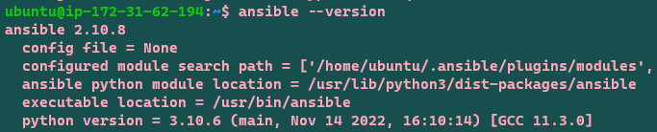

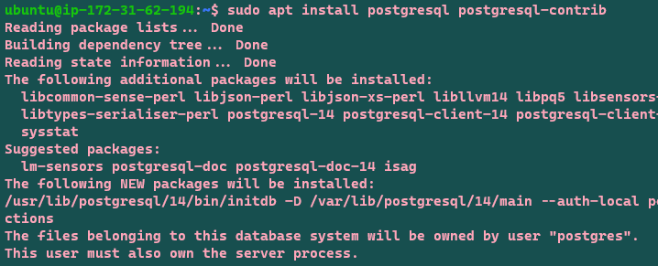

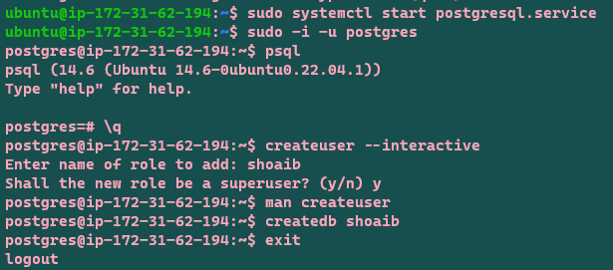

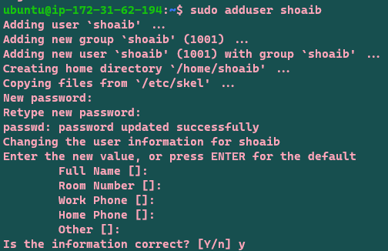

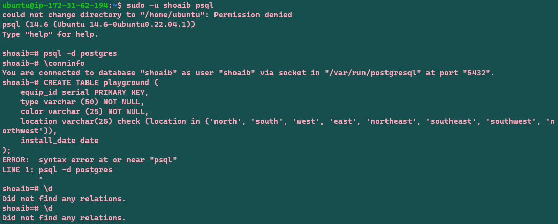

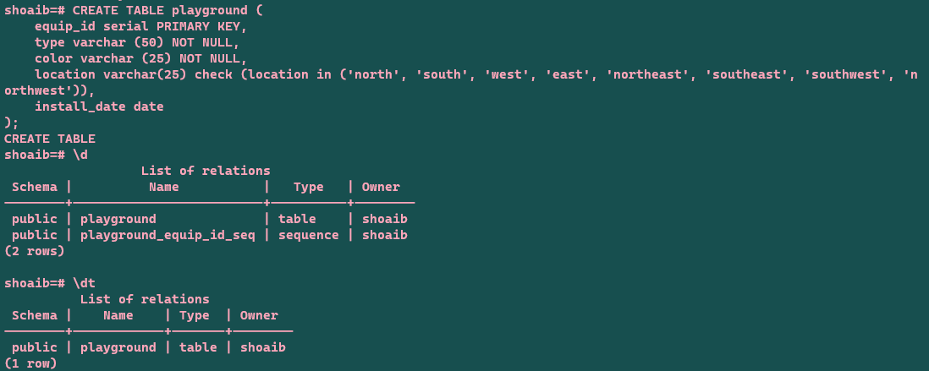

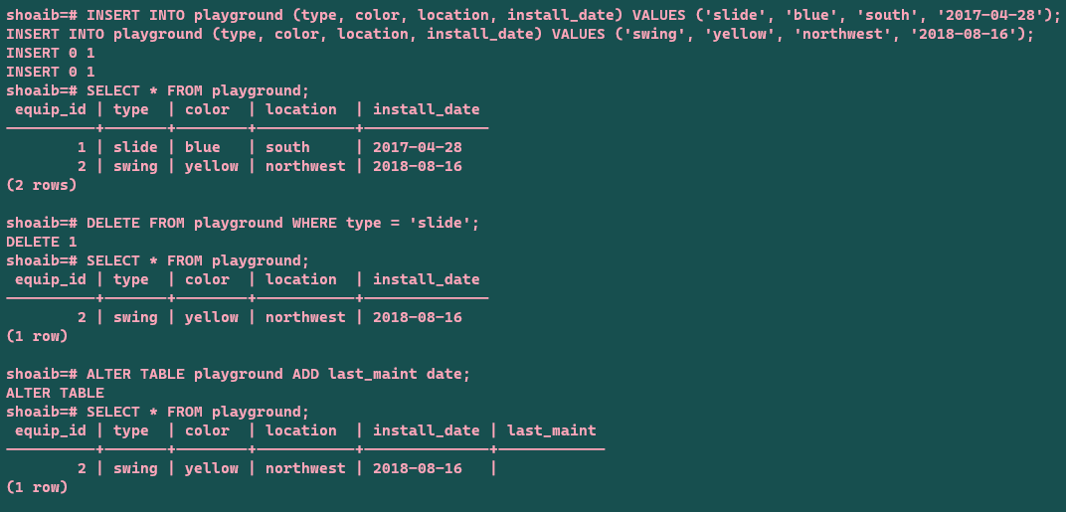

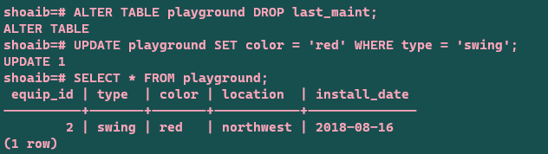

* Now it’s time to execute the same thing in another VM through automation. Firstly, open the “ansible-galaxy” and search for the “postgresql” in search bar and add filter “role”.

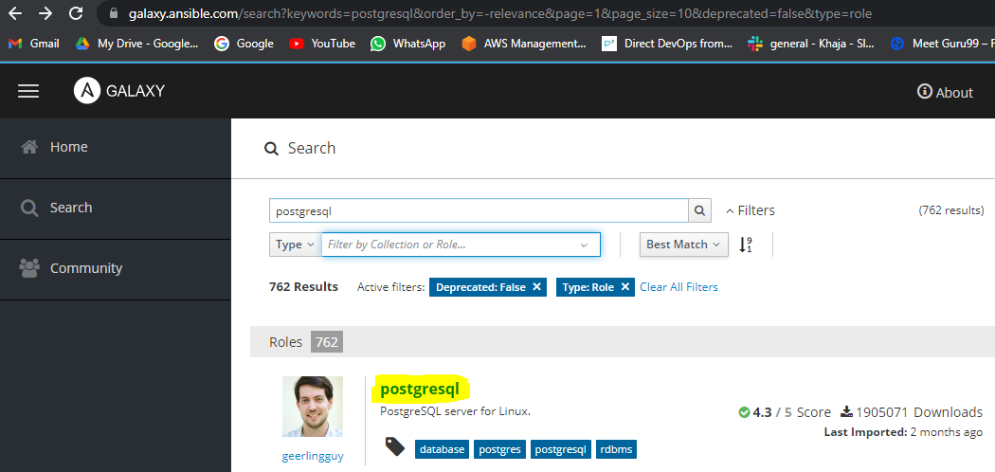

* Open “postgresql” which is highlighted in the above screenshot and this will take you inside it.

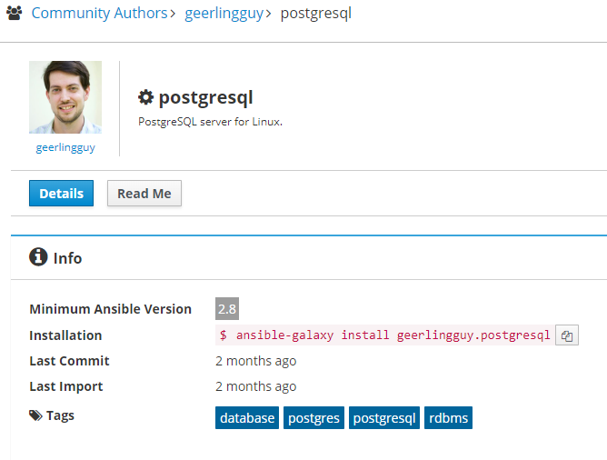

* Now copy “ansible-galaxy install geerlingguy.postgresql” and run it in the VM, then go inside “Read Me” by clinking on it.

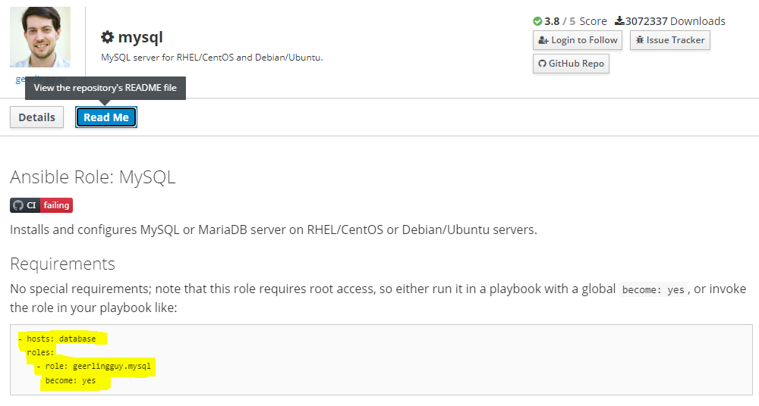

* Copy the highlighted portion shown above and paste it in our YAML file (for example. postgresql.yml), but change the hosts as “localhost” instead of “database”.

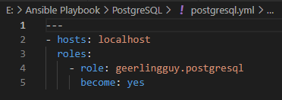

* Run the playbook after the commands as shown below.

